Center for Infrastructure Renewal (CIR) | 1041 RELLIS Parkway | Bryan, TX 77807

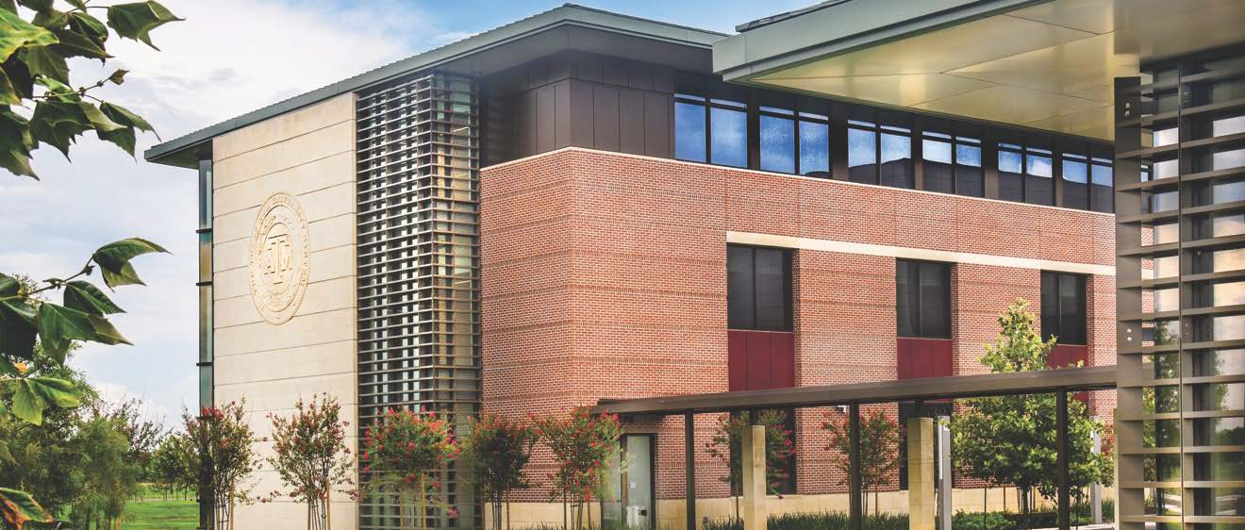

*Note that not all map apps give accurate directions to the CIR.

The CIR is located at the RELLIS Campus, where TX-21 merges with TX-47.
The entrance from TX-21 is currently closed due to construction. Please use the TX-47 entrance to RELLIS.
- Veer right at the circle loop onto RELLIS Parkway.
- Continue on RELLIS Parkway after crossing Bryan Rd intersection.
- Take a right at the next stop sign, at Avenue A, and turn left into the CIR parking lot.
- The CIR is a brick building with a green roof. Please enter through the sliding glass doors.

From the College Station Airport (CLL):
- Turn left under Raymond Stotzer Pkwy (Hwy 60) onto the frontage road heading west.
- Merge onto Raymond Stotzer Pkwy (Hwy 60).
- Take TX-47 N/Riverside Parkway, and follow for 7.7 miles.
- Just before TX-47 N converges with TX-21 W, take a left into the RELLIS Campus.
- Once you have entered RELLIS, follow directions above. A map is attached. We are #20.

From Houston (IAH):
- Follow your desired route from IAH to 290 west (Austin).
- Take the Hwy 6 N/TX-6 N exit towards College Station.
- In 40 miles, take 2818/Harvey Mitchell Pkwy S exit.
- In 14 miles, take TX-47 N/Riverside Parkway exit.
- Follow for 7.7 miles. Just before TX-47 N converges with TX-21 W, take a left into the RELLIS Campus.
- Once you have entered RELLIS, follow directions above. A map is attached. We are #20.

From Austin (AUS):
- Follow your desired route from AUS to TX-21 E.
- Follow for 66.3 miles. Take TX-47 S/Riverside Parkway towards College Station.
- Take the first right into the RELLIS Campus.
- Once you have entered RELLIS, follow directions above. A map is attached. We are #20.

NORTHEAST CAMPUS MAP

RELLIS CAMPUS INFORMATION | RELLIS.tamus.edu
Corporate & Partnerships 979.458.2404
Education 979.458.6037
Physical Address 3100 Texas 47
Bryan, TX 77807
Email RELLIS@tamus.edu
L RD
L
VER HI
SIL

BUILDING NUMBER & NAME
  - RELLIS Academic Complex Phase 1 (Opening Fall 2019)
  - Blinn College Walter C. Schwartz Building
  - Blinn College Faculty Annex
W SH 21
  - TEEX Law Enforcement Office Building
LUZA LN
SH 47 ON RAMP
  - TEEX Law Enforcement Gym
  - Architecture Fabrication and Design Lab
  - Architecture Fabrication and Design Lab ²¹
  - Conservation Research Lab 20
  - RELLIS Campus Administration and Operations Building
(Opening Spring 2019) ^{P}
10 | RELLIS Central Utility Plant
11 | TTI Environmental & Emissions Research Lab
12 | TTI Research Storage Building
13 | RELLIS EHS Hazardous Waste Facility
14 | TTI Machining Facility
15 | TTI Proving Ground Research Support |  | 18
16 | TTI Proving Ground Research Hangar
17 | TTI Office Building
18 | TTI Research Pendulum Test Facility | 17
19 | TEES Energy Systems Lab
20 | Center for Infrastructure Renewal (CIR)
21 | TTI Headquarters Building
22 | Joint Library Facility with University of Texas

19

Maintenance Area
W
RIVERSIDE PW OFF

22
RELLIS P
W
N LN
A
M
R
RAMP
H
E

16 15
SH 47
BRYAN RD

14

13
12
11

PARKING LOT PERMITS
Visitors needing to park at RELLIS should use the Parkmobile
app at transport.tamu.edu/Parking or pay stations to pay by 10
the hour. Or go online to purchase an annual permit beginning August 1.
9

3 2 P

1
LD DR
E
AIRFI
4TH ST
4
E
I
F
R
I
A
R
D
D
L

6 5

7

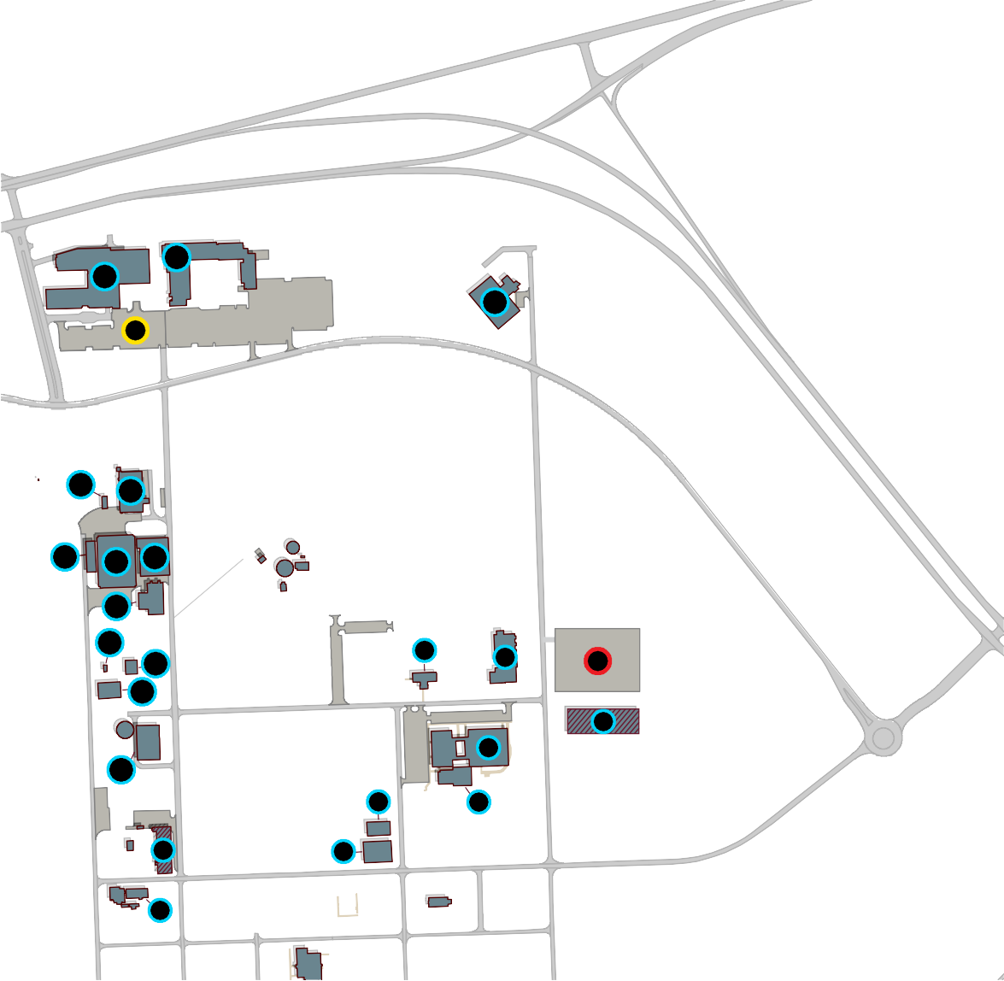
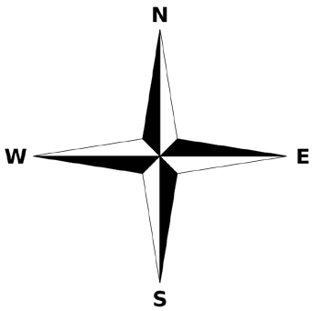
P Parking lot 1000 for Academic Alliance
AVENUE A
FLIGHT LINE RD
AVENUE D
AIRFIELD DR
8
P Parking lot for CIR
6TH ST

