**ECE 615 Homework 3**

**Should Be Done Before First Exam**

1. Manually do an LU factorization on the following matrix **A**. Then manually do a forward and backward substitution to solve for **x** in **Ax**=**b**



2 Code the LU factorization discussed in class for full matrices, along with the forward/backward substitution. To test your algorithm use it to factor and solve the below matrix from question 1. You do not need to code pivoting.

3. Use the Tinney 1 approach to order the following network. Give the permutation vector.

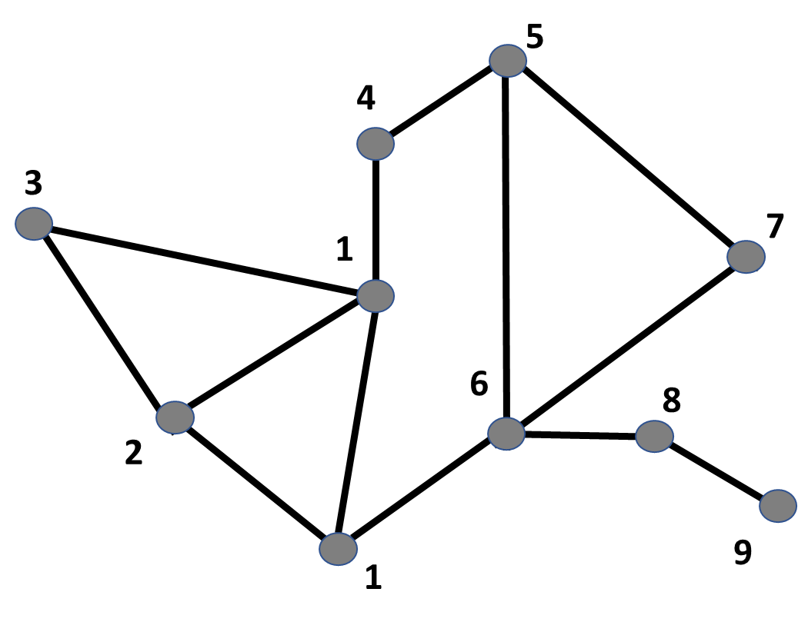

4. Repeat question 3 using the Tinney 2 approach.

5. Using your reordered results from question 4, draw the full factorization path graph for the system.

6. For the B7Flat case (mentioned in class), calculate the dc power flow solution; you can use a matrix package such as Matlab to invert the **B** matrix. Verify your result using PowerWorld.