ECEN 460 Spring 2025

Computer Laboratory Exercise 1

Analysis and Operation of Three-Phase Power Systems

Objectives:
- Learn the basics of using PowerWorld Simulator to model balanced three-phase systems.
- Correct the power factor of three-phase load by proper placement of shunt capacitors.
- Learn the basics of power system operations in the quasi-steady-state (power flow) time frame

Background
Power World Simulator (PowerWorld) is a Windows-based, commercial-grade power system analysis and simulation package that accompanies the ECEN 460 book. For the labs for this semester we will be using either Version 23 or Version 24 (when available). The purposes of integrating PowerWorld with the text are to provide computer solutions to examples in the text, to extend the examples, to demonstrate topics covered in the text, to provide a software tool for more realistic design projects, and to provide the students with experience using a commercial grade power system analysis package. We will be using it extensively in this class both for lecture and lab. The lab computers have the full commercial version, which solves power systems with up to 100,000 buses. The university has a full site license so that students can install it on their laptops for this semester. There is also a free educational version associated with the textbook for this course, which solves power systems with up to 42 buses, that can be downloaded at https://www.powerworld.com/gloveroverbyesarma

This lab introduces PowerWorld, shows how shunt capacitors can be used for reactive compensation, and operate a small power system running as a time domain simulation. Power system analysis requires a model of the power system. With PowerWorld, you can either build a new case (model) from scratch or start from an existing case. Most of the time, including here, we'll start from an existing case. In ECEN 460 using PowerWorld we’ll be assuming a balanced three-phase, 60 Hz ac system. The model of the system can be shown using a oneline diagram. As the name implies on a oneline the actual three phase conductors are shown using a single line. The initial oneline used here is shown in Figure 1.
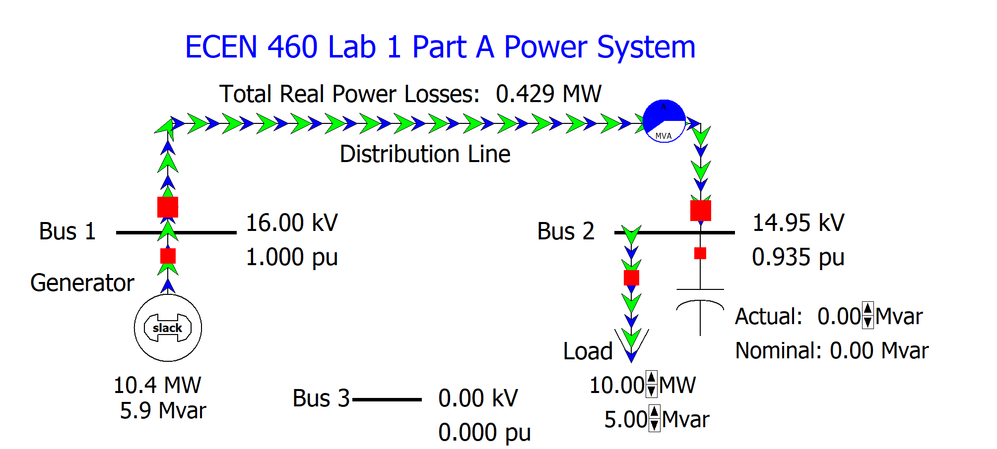

Figure 1: Initial Case Oneline Diagram
In the onelines generators are shown as a circle with a "dog-bone" rotor, large arrows represent loads, and transmission lines are simply drawn as lines. In power system terminology, the nodes at which two or more devices join are called buses. Hence this is a three-bus system, though initially Bus 3 is not connected. In PowerWorld thicker lines usually represent buses; the bus voltages are shown in kilovolts (kV) in the fields immediately next to the buses. In addition to voltages, power engineers are also concerned with how power flows through the system (the solution of the power flow problem will be talked about later in the class and is covered in Chapter 6 of the text). In PowerWorld, power flows can be visualized with arrows superimposed on the generators, loads, and transmission lines. The size and speed of the arrows indicates the direction of flow. Here the green arrows show the flow of real power and the blue arrows the flow of reactive power.

Part A Procedure
1. Start PowerWorld. To open the initial case click File, then select Open Case. This displays the Open Dialog. Select the Lab01A_Start case, and then click Open. The display should look similar to Figure 1.
2. PowerWorld has two major modes of operation. The Run Mode is used for running simulations and performing analysis. The Edit Mode is used for modifying existing cases and building new cases. Like many programs, PowerWorld uses a ribbon interface. To change modes, make sure the ribbon is visible, and then click on either the Edit Mode or Run Mode buttons; both are located in the upper left portion of the display. For the next steps few steps select the Run Mode.
3. One of the unique aspects of PowerWorld is its ability to animate power systems. To start the animation, select the Tools tab on the Ribbon and then click on the green and black arrow button above Solve (i.e., the "Play" button). The simulation is now running, and the green and blue arrows on the oneline should start flowing with green showing the flow of real power and blue reactive power.
4. In this case the amount of nominal reactive power supplied by the capacitor is assumed to be controllable in discrete, 1.0 Mvar increments between 0 and 10 Mvars. Note, the nominal reactive power assumes at rated voltage (here 16.0 kV) while the actual reactive power shown for the capacitor is the reactive power actually being supplied, which varies with the square of the bus voltage. When the simulation is running to change the amount of reactive power click on the up or down arrows next to the capacitor. Record the system losses (due to the resistance in the distribution line) and the load bus voltage as the reactive power is varied between 0 and 10 Mvars in the 1.0 Mvar increments. What value of nominal capacitance minimizes the losses?
5. In the simulation the assumed real and reactive load can also be varied by clicking on the up or down arrows next to the load fields. Change the load to 12.0 MW and 3.0 Mvar. Then repeat the step 4 analysis.
6. Next, we will add load at bus 3 and then connect it to the other buses by distribution lines. First switch to Edit Mode. Load can be inserted graphically by selecting Network, Load, and then clicking on bus 3. The Load Options dialog appears, allowing you to set the load parameters. Note that the load was automatically assigned to bus 3. Leave all the fields at their default values, except set the orientation to "Down," and enter 10.0 in the Constant Power column MW Value field. As the name implies, a constant power load treats the load power as being independent of bus voltage; constant power load models are commonly used in power system analysis. By default PowerWorld "anchors" each load symbol to its bus. This is a handy feature when changing a drawing since when you drag the bus the load and all associated fields move as well. Note that two fields showing the load's real (MW) and reactive (Mvar) power were also auto-inserted with the load. You should resize the fields using the Draw, Format, Font command.
7. As you make changes to the model be sure to be saving the cases. You can do this by selecting, File, Save Case As. Select a new file name to avoid overwriting the initial one.
8. Now we need to join the bus 3 load to the rest of the system. We'll do this by adding a line from bus 2 to bus 3. Select Draw, Network, Transmission Line and then click on bus 2. This begins the line drawing. During line drawing PowerWorld adds a new line segment for each mouse click. After adding several segments place the cursor on bus 3 and double-click. The Transmission Line/Transformer Options dialog appears allowing you to set the line’s parameters. Note that PowerWorld should have automatically set the "from" and "to" bus numbers based upon the starting and ending buses (buses 2 and 3). If these values have not been set automatically then you probably did not click exactly on bus 2 or bus 3; manually enter the values. Next, set the line's Series Resistance (R) field to 0.3, the Series Reactance (X) field to 0.6, and the MVA Limits Limit (A) field to 20 (transformer and transmission line modeling will be covered in future lectures). Select OK to close the dialog. Note that PowerWorld also auto-inserted two circuit breakers and a round "pie chart" symbol. The pie charts are used to show the percentage loading of the line. You can change the display size for these objects by right-clicking on them to display their option dialogs.
9. Repeat this process, except add a line between bus 3 and 1 with the same impedance and limit values.
10. Switch back to Run Mode, start the simulation, make sure the Bus 2 load is again 10.0 MW and 5.0 Mvar. At the end of this step your oneline should be similar to what is shown in Figure 2.
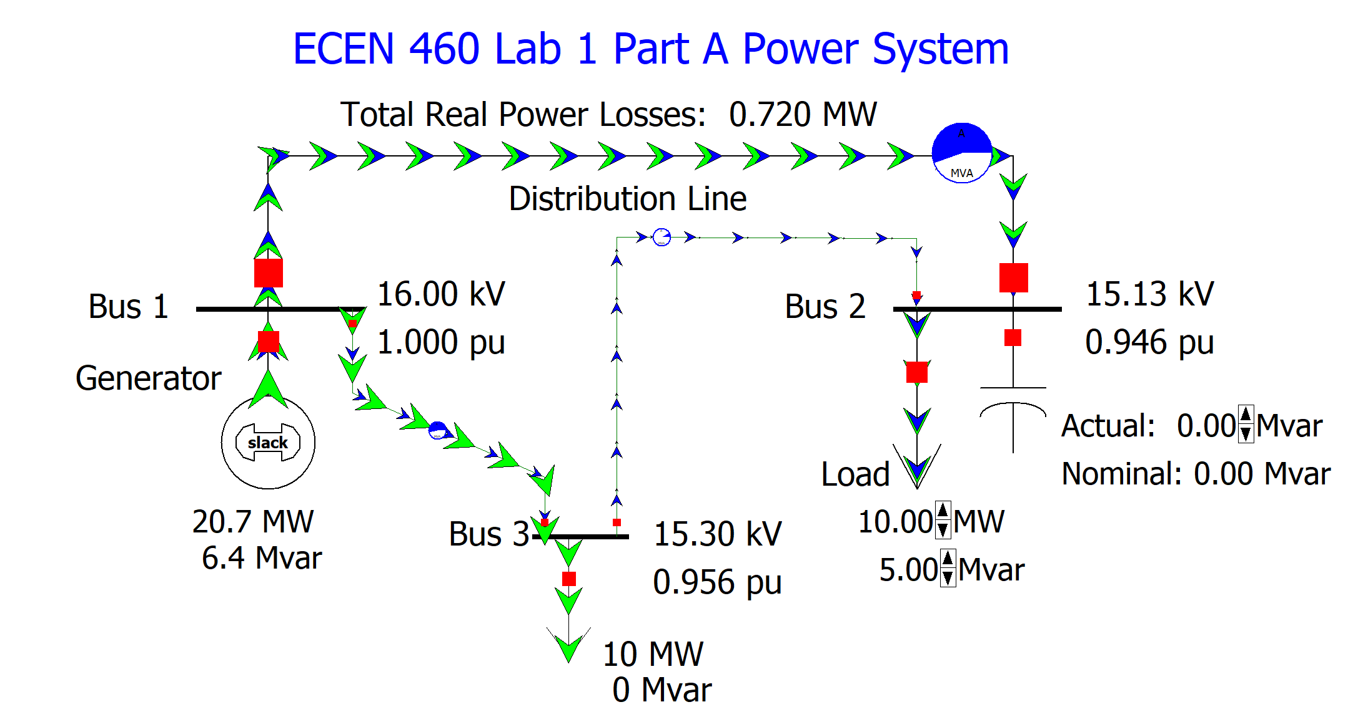
Figure 2: Oneline Diagram After Line Addition
11. Repeat the step 4 analysis.
12. Save an image of your final oneline as a *.png or *.jpg file for your report. To save an image, right-click on a black portion of the oneline. This will display a local menu. Select Export Image to File and save it in one of your directories.

Part B Procedure
During this part of the lab you will be operating a small power system in what is known as the quasi-steady-state time frame. That is, how the power system would appear if we neglected all dynamics shorter than say a few seconds, and assuming the system frequency was constant (at 60 Hz). During the experiment you are operating a power system running as a time domain simulation.

- Start PowerWorld Simulator. Open the Lab01B_Bus3 case. This is a three bus, two balancing authority (BA) area case that was demonstrated during lecture. You’ll be operating the “Home Area,” which consists of buses 2 and 3; the “Other Area” just has bus 1. The case is set to run a four hour time-domain simulation, modeling a load increase between 6 am and 10 am. The simulation is set to run at 30 times real-time, meaning the four hour simulation will run in eight minutes. The oneline for this system is shown in Figure 3. Note the location of the Start, Pause and Reset buttons in the top menu, and also the simulation time shown on the bottom ribbon.
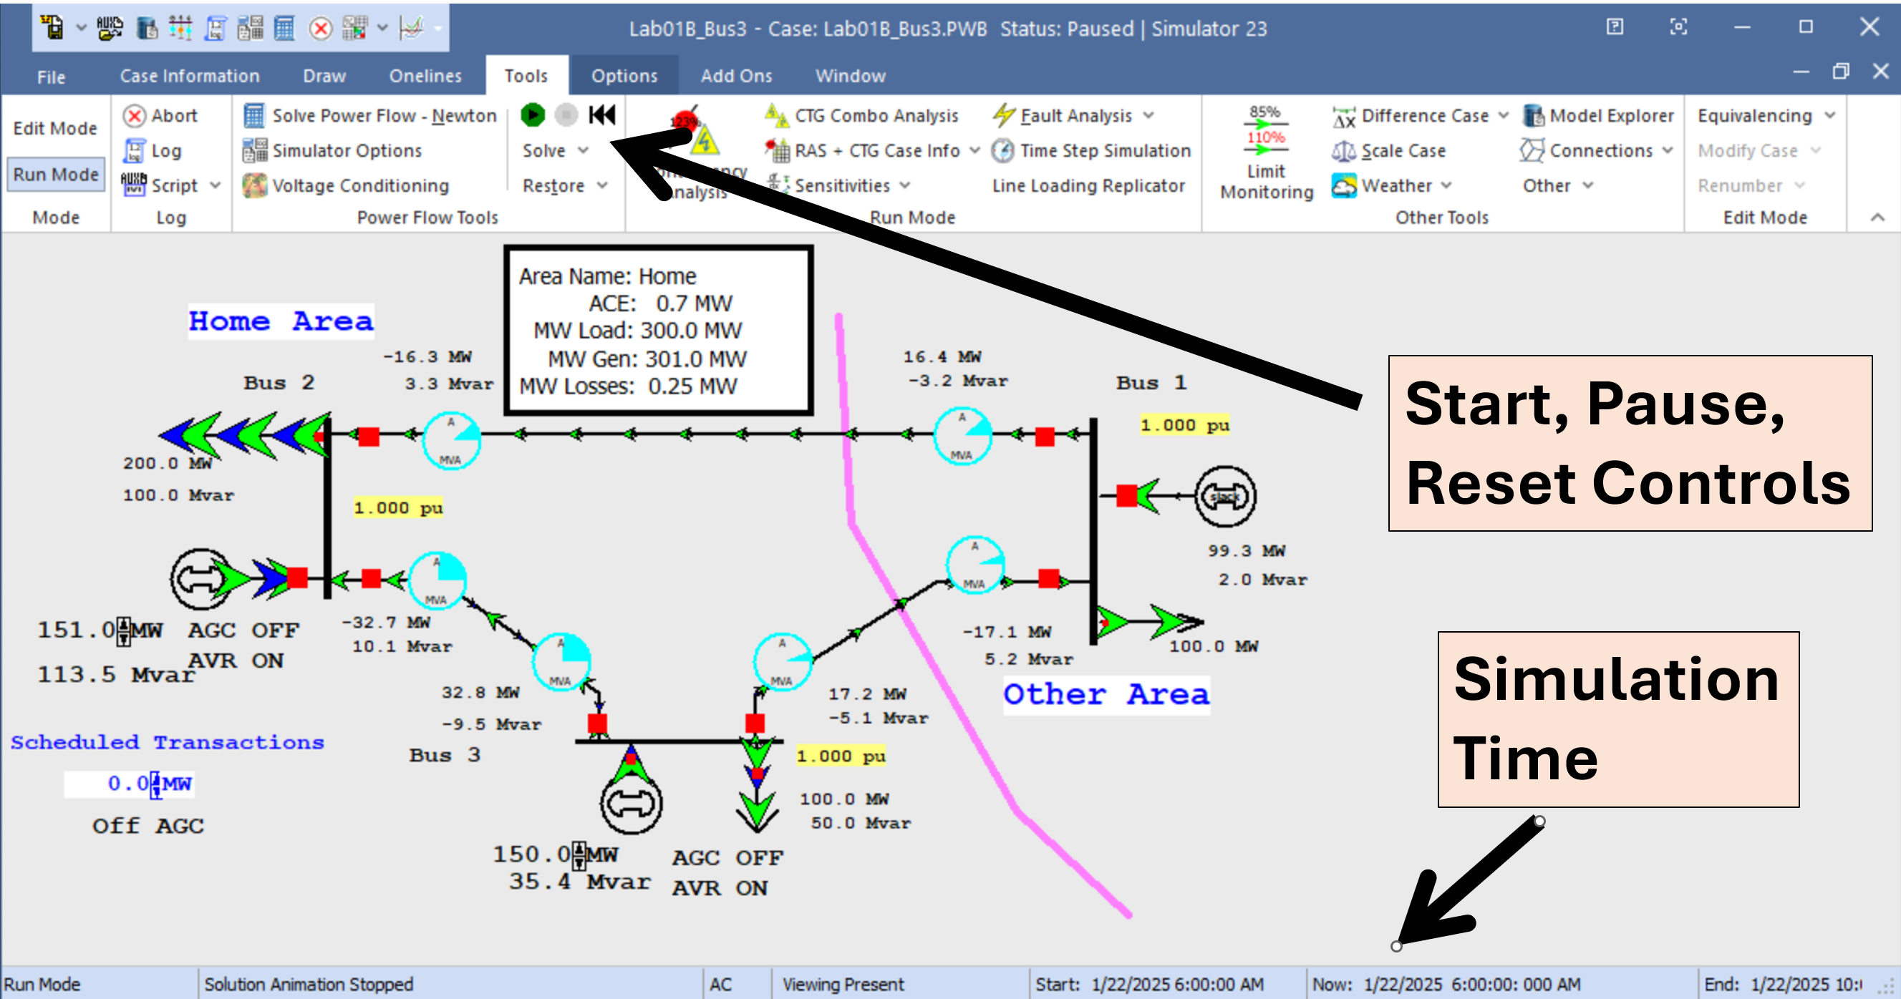
Figure 3: Three Bus, Two Area System
2. Select Tools, green start arrow to start the simulation. Notice that the simulation time advances at a rate of 30 times real-time. Observe the simulation with a mind towards answering the questions in the Report Section. When the simulation time gets to about 8 am use the red pause button to pause the simulation. Note bus 1 is the slack bus, a concept we’ll talk more about in the book Chapter 6 material; its purpose here is to ensure that for the entire system the total generation is always equal to the total load plus losses.
3. With the simulation paused at about 8 am save an image of the oneline. You can do this either by using the Windows Print Screen, or else by right-clicking in a blank area of the oneline to view the local-menu, then selecting Export Image to File. You will need to include this image in your report, and also will use it to verify conservation of real and reactive power at all three buses.
4. Again select Tools, green start arrow to continue the simulation. Run it until the end (10 am simulation time). Record the simulation time at which any transmission lines reach 100% loading and include these times (if any) in your report.
5. The next step is to consider how changes in the generation and line status affect the system. Reset the simulation by selecting Tools, reset symbol (alternatively, you can just reopen the case), and then restart it. Using your engineering judgment play around with the simulation by using the up/down arrows next to the buses 2 and 3 generator MW fields to adjust their generation and by clicking on the red circuit breaker symbols to change their status. Direct your exploration to address the questions that are needed for your report.
6. The next step is to run the system changing the generation in order to keep the area control error (ACE) close to zero. Again reset the simulation. Then, to display the ACE strip chart, right-click on the ACE field in the white box; select Show Strip Chart. This shows the Strip Chart Window Options dialog. Select OK to use the defaults (if desired you can change the colors to personalize your strip chart). Selecting OK will display a strip chart that shows the ACE for the Home Area. Resize and move this window as desired.
7. Start the simulation. Use the up/down arrows next to the buses 2 and 3 generator MW fields to adjust their generation to keep the ACE close to zero. Run the simulation until the end. At the end of the simulation, save an image of your ACE chart. You can do this by right-clicking in an empty portion of the ACE chart, and selecting Export Image.
8. As the last step with this case, we’ll use automatic generation control (AGC) to automatically control the generation and then will explore the implementation of power transactions. First reset the simulation. Then left-click on the “OFF AGC” field to toggle it to “Part. AGC.” This does a participation factor AGC (you’ll figure what this is experimentally). Click on the “AGC OFF” (or “AGC ON”) fields by each generator to set the field to “AGC ON” to tell the simulation both generators can participate in AGC. Start the simulation. Observe the simulation long enough to address the lab report questions. Pause the simulation once you’ve gathered sufficient data; feel free to run the simulation multiple times if you need more results to answer the report questions.
9. With the Home Area (and both its generators) on AGC, modify the Scheduled Transactions field to implement power transactions between the Home Area and the Other Area. Play around with the scheduled transactions to address the report questions. Save an image of the oneline showing a non-zero scheduled transaction for your report.
10. Last, in the spirit of friendly competition, we’ll consider the 37 bus system (which you’ll see again later in the semester) shown in Figure 4. This case is setup so the load, which is originally 1000 MW, continuously increases at a rate of 500 MW per hour of simulation time. This simulation is set to run at 60 times real-time. So rather quickly the system will reach a point of maximum loadability, which will be indicated by a blackout! The case is also set to show a voltage contour, in which red indicates decreasing voltages. Your goal is to adjust the generation at nine generators (indicated by the magenta background fields) to forestall the inevitable blackout for as long as possible. All generators change at 10 MW per click. Save an image in your report showing that maximum load you achieved at the point of blackout. Feel free to pause the simulation to consider your strategy, and to run the case as many times as time allows (note it may be better just to reload the case after each run rather than trying to reset it). You may wish to run it once initially just to see how it collapses. You may not open any loads, but you can open generators and/or transmission lines. We’ll see who gets the highest total load! However, only images that have “Total Losses” less than 250 MW will count.
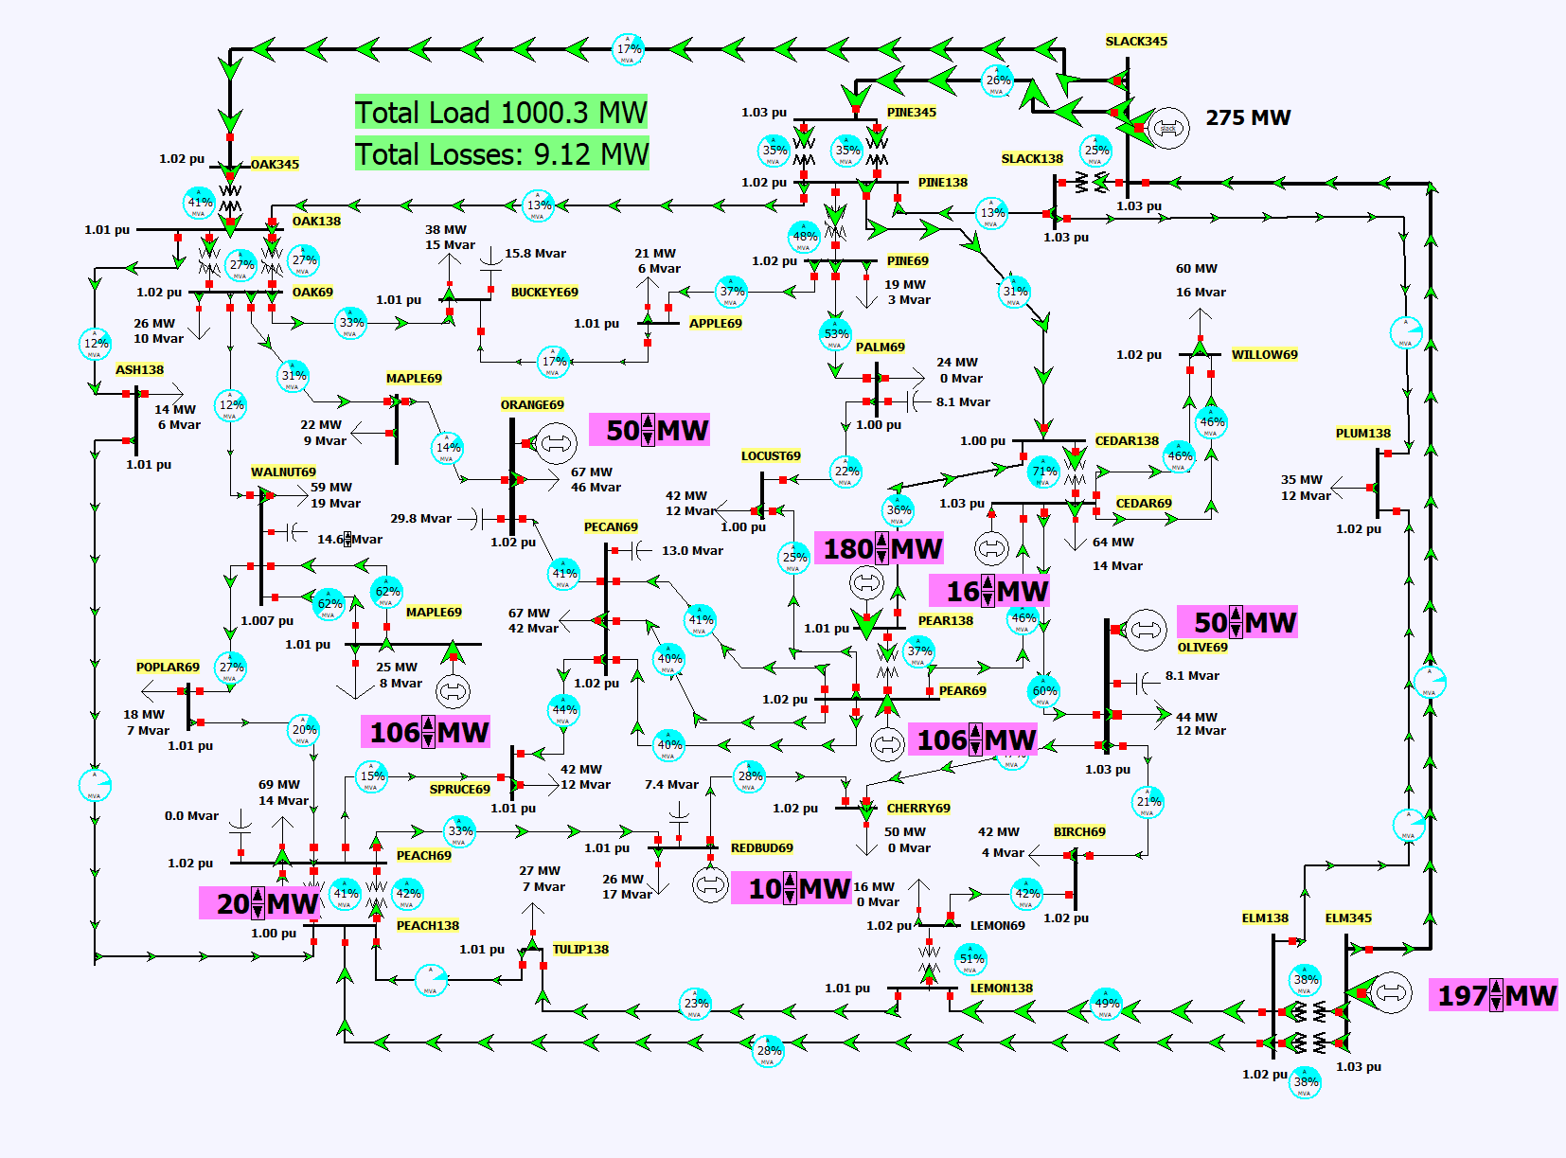
Figure 4: 37 Bus Extreme Loading Scenario Case

Report:
For both Part A and Part B, provide a step by step account of the procedure you followed and the results you have obtained. Answer all questions appearing in any of the steps of the procedure. Also include the final image from Part A, step 11.

For Part B, answer the following questions in your report:

1. In step 2, comment on what was changing in the simulation and what was not changing. Why?
2. With the image you saved in step 2 when the simulation was paused at 8am, verify the conservation of real and reactive power at all three buses. How does this relate to Kirchhoff’s current law? Include this image in your report.
3. In step 4 report the time at which any transmission line reaches 100% loading, and provide an explanation for why. Include the image you saved at the end of the simulation in your report.
4. In your report, address what insights about the system you gained from your step 5 exploration. Example topics you might address include how changes in the generation affect the line flows or how changes in line status affect the system losses.
5. For step 7, turn in a copy of your ACE chart. Why was the ACE changing? Were both generators equally affective in modifying the ACE? Which ones did you use? Why? What would have happened to the ACE if one of the generators had opened?
6. For step 8, how is the ACE now varying? How is AGC adjusting the outputs of the two generators?
7. For step 9, how does a scheduled transaction affect the power flow on the tie lines, and how does it affect the ACE? Include an image showing the system with a scheduled transaction. Do you think there is a limit on the transaction amount? Is it impacted by the system loading?
8. Recognizing that no simulation can exactly duplicate reality, comment on which aspects of this simulation seem most realistic and which seem to be least realistic.
9. For the 37 bus case, what was your maximum load level? Turn in a screenshot of your system at the blackout point. Comment on the strategy you used to maximize the system’s loading.

